**Response Threshold Model for Nutrient Allocation**

Objective

The ability of animals to acquire and consume nutrients in optimal relative amounts has a strong impact on their lifespan and/or fecundity. In response to this evolutionary pressure, most animals employ foraging mechanisms that allow them to choose food items to provide nutrients in these optimal relative amounts. Social insect colonies are capable of defending such intake targets. Although this regulatory process is beginning to be understood on the colony level in leafcutter ants, the mechanisms shaping individual foraging decisions, and how individual foraging decisions are coordinated to allow for consistent and accurate nutrient collection at the colony level, remains unknown.

A simple explanation of this behavior is that there are foraging specialists, some workers may focus more on attaining some types of nutrients while others specialize in other nutrients. By regulating the proportion of specialists for each type of nutrient, the colony can ensure that an intake target is met given that there are enough variable food sources in the environment. However, in a binary choice experiment where individually-marked leafcutter foragers could choose one of two food items with different relative proportions of carbohydrates and protein, specialists did not seem to be present. A naive expectation of specialists is that they will selectively choose one type of food item over the other and that this bias would be correlated with the number of foraging trips for that ant. No such correlation was found.

Here, we seek to elucidate this mismatch between expectation and reality by building a model of individual foraging decisions in the context of this experiment. The model is based on the concept of response thresholds, which are a potential proximate mechanism for division of labor in social insects. The response threshold hypothesis posits that ants are sensitive to signals in the environment that measure the degree to which different tasks need to be performed. Different ants might be more sensitive to different signals (i.e. have a lower response threshold), and thus become specialists in those tasks. Here, the task-associated stimulus is the difference in a colony’s current nutritional stores and the ideal intake target. By manipulating the response thresholds of virtual ants, we can generate colonies with varying numbers of specialists and see if we can reproduce the colony-level behaviors observed in the experiment. We can also compare these response-threshold modulated behaviors to that of a null model where ants randomly select food items. Finally, we might be able to make predictions about future experiments by simulating scenarios not yet tested in the lab.

Response thresholds as a softmax function

Response thresholds are typically modeled probabilistically. That is, different values of the task-associated stimulus (x) yield different probabilities of a response P(x, 𝛉). This is usually written in the form:

P(x, \theta) = \frac{x^k}{x^k+\theta^k}

which generates an s-shaped (sigmoid) probability curve. Here, θ is the inflection point (the response threshold) of the curve while k determines the steepness of the curve. This equation, however, breaks down when x < 0, as it is either undefined on the real number line for fractional values of k or tends to increase for whole numbers of k. This latter property can be problematic in cases where there is a negative task-associated stimulus. Traditionally, task-associated stimuli are thought to be physical cues that can only take on positive real values (Bonabeau et al., 1996). Modeling them this way works for cases where the social insect colony wants to either minimize the stimulus (such as with brood pheromone; Pankiw et al., 1998) or maximize it (such as the food larder, Lynch et al., *in prep*). However, there are cases where an intermediate value of the stimulus is preferred, such as with nest temperature (Weidenmüller, 2004) or distance from the nest entrance (Wehner, 2020). In these cases, it may make sense to model the task-associated stimulus not as the raw cue, but rather as a distance from an objective. Positive distance values may trigger one set of behaviors while negative values trigger a different set. For instance, bees fan at high temperatures, but will incubate brood at low temperatures (O'Donnell & Foster, 2001). The probability of response for one set of tasks should approach 0 as the distance becomes increasingly negative (such as the probability of fanning at low temperatures) while the probability of the other task should increase (such as the probability of incubation). The opposite should happen when the distance becomes increasingly positive. This illustration also highlights the importance of integrating the probability of performing multiple tasks simultaneously. If P(x, 𝛉) is used for every task independently, then the sum of their probabilities may be greater than 1.

Multiple approaches have been proposed to solve this issue (Wu et al., 2018; Jeanson et al., 2007), but ultimately P(x, 𝛉) has no natural extension for two or more tasks.

Here, we seek to model a scenario where a colony will try to attain an intake target, so its current dietary state can either be too protein or carbohydrate rich. The colony can choose to either forage a more carbohydrate-heavy food item, or one that has relatively more protein, and by biasing the collection of one over the other the colony can eventually reach its intake target. This situation is akin to the temperature example, where if the current dietary state is too high in carbohydrates, then the probability of choosing the carbohydrate-rich food item should diminish while the probability of choosing the protein-rich food item should increase. Negative distances and multiple tasks can simultaneously be measured by the softmax function \phi(\vec z, \vec \theta):

\phi(\vec z, \vec \theta)_i = \frac{e^{k(z_i-\theta_i)}}{\sum_{j=1}^Ke^{k(z_j-\theta_j)}}

where the vector \vec zcontains the task associated stimuli for K-1 tasks, and the index i represents state i (i = 1 is the rest state). The denominator is a partition function which guarantees that the sum of probabilities across all states sums to 1 (Lynch & Pavlic., *in prep*). To see that this function can also incorporate negative values, we can solve \phi(\vec z, \vec \theta) for the case where K = 2 (Lynch & Pavlic., *in prep*) which yields the logistic function:

S(x, \theta) = \frac{1}{1+e^{-k(x-\theta)}}

whose limit is 0 when x approaches negative infinity regardless of the value of k or 𝛉 (Lynch & Pavlic., *in prep*). The softmax function, then, can be used to model the probability of foraging for different food items in this experiment.

Leafcutter Experiment Markov Model

While we can generalize this approach to include any number of nutrients, we will investigate the case where we only consider the collection of protein and carbohydrates. In this model, a colony of N ants can choose to collect one of two food sources: A or B. Each of these contain different amounts of carbohydrates and protein. By definition, the carbohydrate content of A, cA (the amount of carbohydrates collected per trip), is greater than that of cB . Therefore, the slope of the nutrient rail of A (sA = cA/pA , where pA is the amount of protein collected per trip to A) is also greater than sB. Each ant n (n ∈ {1, 2, …, N}) also has the choice to stay in the nest and rest. The colony m’s (m ∈ {1, 2, …, M}) goal is to defend the intake target s\*. That is, they want to maintain a certain ratio of carbohydrates to protein rather than a specific amount of each. The colony’s nutritional state at time t (t ∈ {0, 1, 2, …, T}) is (pmt, cmt ). Each ant is exposed to a task-associated stimulus which is the euclidean distance between (pmt, cmt ) and the nearest point (pmt\*, cmt\*) on the line G that defines the intake target (Fig. 1).

To measure the distance dmt between (pmt, cmt ) and (pmt\*, cmt\*), we must first find the slope of the line that connects A and B that contains (pmt, cmt ) without bias. The slope of this line is the negative reciprocal of the average slope of A and B: s_d = -\frac{1}{(s_A+s_B)/2}. The equation for this line is c = s_dp + I, where I is the intercept. By setting c = cmt  and p = pmt, we can solve for I: I = c_{mt} + s_dp_{mt}. To solve for pmt\*, we can find the point where this new line and G intersect. The governing equation for G is c_{mt}^*= s^*p_{mt}^*, so s_dp_{mt}^*+I = s^*p_{mt}^*. Solving for pmt\* yields p_{mt}^* = \frac{I}{s^*-s_d}. Plugging this into the equation for G gives c_{mt}^* = s_d\frac{I}{s^*-s_d}. With these points we can measure dmt, d_{mt} = \sqrt{(p^*_{mt}-p_{mt})^2 + (c^*_{mt}-c_{mt})^2}.

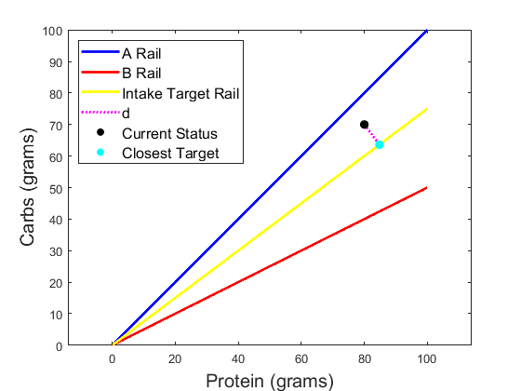

Figure. 1: Geometric framework of a hypothetical experiment. Here, the current nutritional status of a leafcutter colony is given as the black dot, which is a distance d from the colony’s intake target (teal point). The colony can choose to forage from either food item A (blue line) or food item B (red line).

This value dmt can only take on positive values, we must introduce a sign change for when (pmt, cmt ) is closer to A or B. To do this we can define dmt’ as positive dmt when (pmt, cmt ) is above G and as negative d when it's below G:

d_{mt}' = \left\{
\begin{array}{ll}
      -d_{mt} & c_{mt}/p_{mt}\leq s^* \\
      d_{mt} & c_{mt}/p_{mt} > s^* \\
\end{array} 
\right.

The decision-making process for each ant n can be modeled as a discrete time Markov chain as only the current nutritional status matters rather than nutritional history. Each ant can be in one of 3 states (Fig. 2). An ant can forage for food items A or B (A, B), or they can return to the nest to rest (R). Therefore, K = 3. After gathering either food item, they must rest for at least one timestep before they can do another action. The probability that an ant will transition to any of these states will depend on that ant’s response threshold to the task-associated stimulus for that particular state. The probability that ant n from colony m at timestep t will be in state i is given by \phi_{nmt}(\vec z, \vec \theta)_i. The vector \vec zcontains the task associated stimuli for each state while the vector \vec \thetacontains the response thresholds for each state:

\vec z =  \begin{bmatrix}-d'_{mt} \\ d'_{mt} \\ r_{nm} \end{bmatrix},
 \quad 
\vec \theta = \begin{bmatrix}\theta^{A}_{nm} \\ \theta^{B}_{nm}   \\ 0 \end{bmatrix}


We assume that the response threshold for collecting A depends on negating a negative d’. A negative d’ indicates that the colony is closer to B than A, and thus should start foraging for A. Each threshold is drawn from a uniform distribution between 0 and D, where D is a free parameter controlling the highest possible threshold. As θnm must be positive, then positive values of d’ will ensure a higher probability of a response, so the negative d’ must be negated to ensure a higher probability of foraging from A. However, as this task-associated stimulus is not negated for B, the probability of foraging for B will be small. The opposite holds true when d’ is positive. This means that the colony is currently closer to A than B, and thus should start foraging from B. As d’ is negated for A, the probability of foraging from A is small, but the probability of foraging for B stays high.

We also assume that each individual has independent response thresholds for every state. These thresholds are fixed throughout time, and are independent of other ants within the colony. Each ant also has a resting tendency labeled as rnm, which ideally is on the same scale as the task-associated stimuli for other tasks. As there is no known signal for not performing a task, we assume the response threshold is 0 so rnm can function as a free parameter independent of other factors. As with the response thresholds, rnm ~ U(0, D).

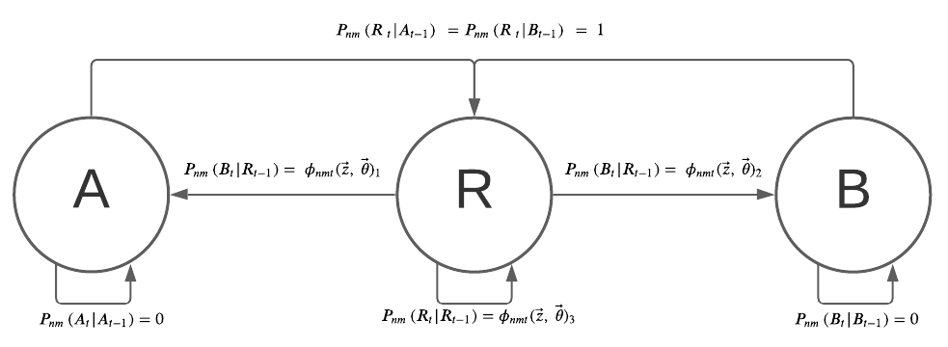

Fig. 2. Markov chain for each ant n in colony m at timestep t.

Finally, we must define a function that updates (pmt, cmt ). Let nAmt be the number of ants from m foraging A at time t while nBmt is the number of ants foraging B:

c_{mt} = c_{mt-1} + n_{Amt}c_A + n_{Bmt}c_B

p_{mt} = p_{mt-1} + n_{Amt}p_A + n_{Bmt}p_B

We initiate these variables cm0 = pm0 = 0. We assume that food stores can only increase over the short time scale of the experiment and that ants would never remove a food item. Note that decisions are made simultaneously by ants rather than sequentially. At a given timestep, all ants make decisions based on the colony’s current nutritional status. Status does not update after each individual’s decision, it only updates only after all ants have had the opportunity to switch states. Refer to Table 1 for a description of all variables used in this model.

|  |  |  |
| --- | --- | --- |
| **Symbol Type** | **Symbol** | **Description** |
| Free parameter | N | # Individuals per Colony |
| Free parameter | M | # Colonies |
| Free parameter | T | # Timesteps |
| Index | n | Index for individual |
| Index | m | Index for colony |
| Index | t | Index for time |
| Index | i | Index for state |
| Constant | K | Number of states for each ant |
| State | A | Food item with higher carbohydrate content |
| State | B | Food item with higher carbohydrate content |
| State | R | Resting in nest box |
| Free parameter | cA | Amount of carbohydrates collected or removed from A for a single ant in a single timestep |
| Free parameter | cB | Amount of carbohydrates collected or removed from B for a single ant in a single timestep |
| Free parameter | pA | Amount of protein collected or removed from A for a single ant in a single timestep |
| Free parameter | pB | Amount of protein collected or removed from B for a single ant in a single timestep |
| Constant | sA | Slope of nutrient rail for A |
| Constant | sB | Slope of nutrient rail for B |
| Constant | s\* | Slope for intake target nutrient rale |
| Variable | sd | Slope of line connecting current nutritional status to intake target |
| Variable | d | Distance between current nutritional status and intake target |
| Variable | d’ | d with indication as to what side of the intake target the colony is on |
| Variable | c | Current value of carbohydrates present in colony |
| Variable | p | Current value of protein present in colony |
| Vector | z | Collection of task-associated stimuli |
| Vector | θ | Collection of response thresholds |
| Function | P(x,θ) | Classical response threshold probability curve |
| Function | σ(x) | Softmax function |
| Function | S(x,θ) | Response threshold logistic function |
| Function | ɸ(x,θ) | Response threshold softmax function |
| Constant | r | Tendency of ants to rest |
| Free parameter | D | Maximum possible response threshold |
| Variable | nA | Number of ants collecting A |
| Variable | nB | Number of ants collecting B |
| Variable | nR | Number of ants resting |
| Free parameter | k | Steepness of logistical curve |

Table 1: Descriptions of variables used in simulations.

Simulation Results

We can replicate the experiment *in silico* by setting several free parameters equal to values used in the experiment. In the experiment, colonies were exposed to one of 5 different nutrient pairs, which each had different proportions of carbohydrates and protein (Table 2). Each food item contained a particular amount of protein and carbohydrates associated with it, so we can set the values of cA, pA, cB, and pB. We can also derive the intake target, s\*, for each colony from the experiment. Although multiple colonies were exposed to each treatment in the experiment, we only simulate 1 colony per treatment, so M = 5. There were around 100 unique foragers per experiment, so we set N = 100. Finally, we set T = 200 as this gave us approximately the same number of foraging trips that we saw in the experiment. This leaves only D and k as free parameters we cannot measure, so we can perform a sensitivity analysis on these parameters.

|  |  |  |  |  |  |
| --- | --- | --- | --- | --- | --- |
| **Experiment Nutrient Ratio (A vs B)** | **Intake target (s\*)** | **cA (g)** | **pA (g)** | **cB (g)** | **pB (g)** |
| 1:10 vs 1:2 | 6.9 | 0.7504 | 0.075 | 0.5617 | 0.2809 |
| 1:10 vs 1:4 | 6.3 | 0.7504 | 0.075 | 0.6535 | 0.1634 |
| 1:10 vs 1:6 | 7.4 | 0.7504 | 0.075 | 0.6883 | 0.1152 |
| 1:9 vs 1:4 | 6.5 | 0.7302 | 0.0811 | 0.6535 | 0.1634 |
| 1:9 vs 1:6 | 7.3 | 0.7302 | 0.0811 | 0.6883 | 0.1152 |

Table 2: Values of free parameters derived from experimental data

Simulations where D = k = 2 bear a striking resemblance to the real colonies. Like with the real colonies, the nutrient trajectory is linear, meaning that roughly the same proportion of ants retrieve food from A or B over time (Fig. 3). The simulated ant colony also doesn’t stray far from the intake target at any point in time, meaning that nutrients are tightly regulated with this response threshold system. The distributions of foraging trips and proportion of trips to A and B are also similar between real and simulated ants (Fig. 4).

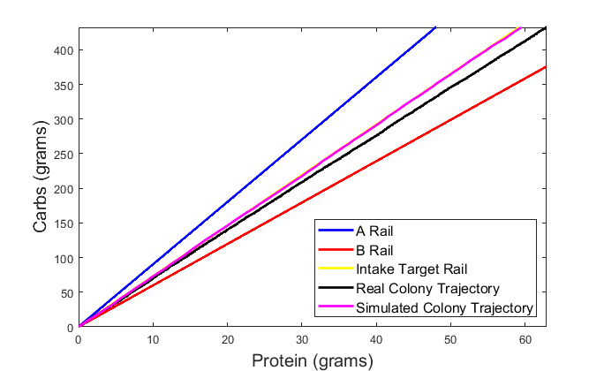

Figure 3: Nutrient trajectory of a real ant colony (black) versus a simulated ant colony (magenta) for a single nutrient pair (1:10 vs 1:6). The simulated colony hugs the intake target rail tightly, to the point where you can’t even see the intake target in the graph.

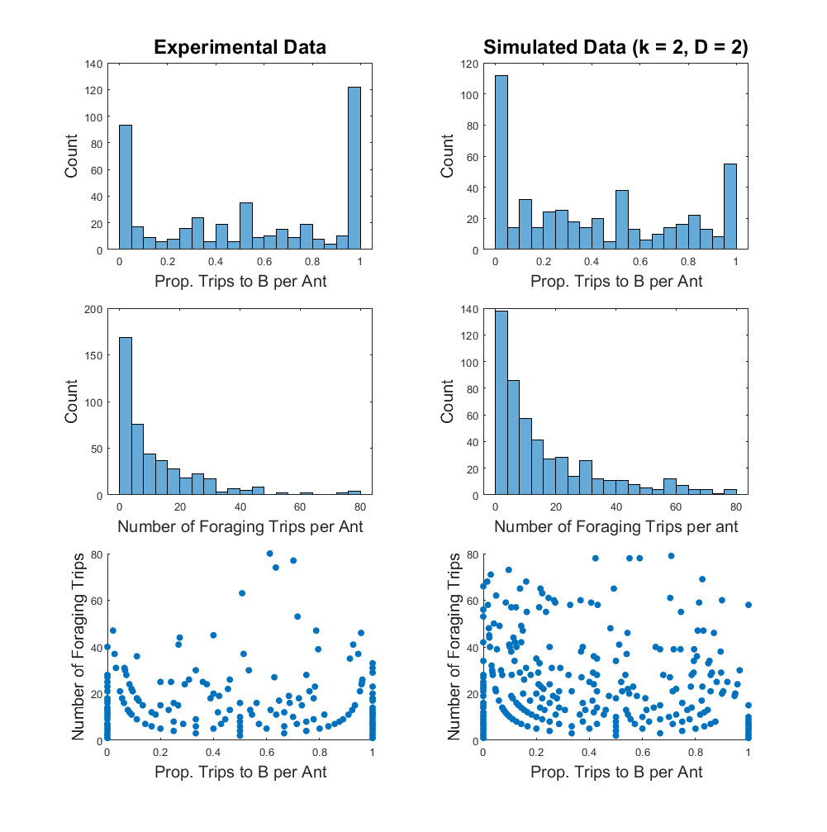

Figure 4: Experimental data is presented in the left column, while simulated data is in the right. Data is pooled across colonies and across different diet pairings. The first row shows the proportion of trips each ant took to food item B, the second row shows the total number of foraging trips per ant, and the final row plots these values against one another. In these simulations, k = D = 2.

The relationship between foraging trip number and the proportion of trips to a food item are the direct result of the relative values of an ant’s response thresholds for A and B. Figure 6 shows a more detailed version of the last panel in Figure 4. There, color indicates the difference in thresholds (θAnm - θBnm) and size of each point indicates the sum (θAnm + θBnm). Ignoring the effect of rnm, we can see that the proportion of times each ant spends on one food item or another depends on the difference in thresholds (partial correlation = 0.712, p-value < 0.001). If this difference is very negative (meaning θAnm< θBnm) then the ants will tend to forage from A, as low response thresholds are associated with performing the task. Conversely, if the thresholds are about the same (θAnm ≈ θBnm), the difference is near 0 and they spend equal amounts of time on each task. On the other hand, when both thresholds are small, the sum is also small, and the ant tends to forage more often (partial correlation = 0.474, p-value < 0.001), which is why small points in Fig. 5 tend to cluster in the middle of the graph and tend to be higher.

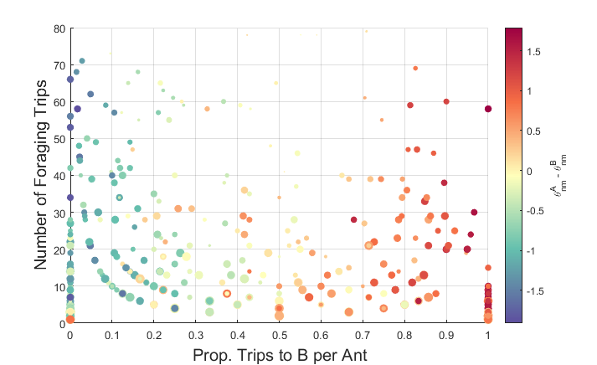

Figure 5: The x-axis shows the proportion of trips each simulated ant took to B, while the y-axis gives the total number of foraging trips to either food item. Color gives the difference in response thresholds while size gives the sum of the thresholds.

When thresholds are randomly drawn and are independent of one another (independent both across and within individuals), then the simulated colony’s behavior mimic’s that of the real ant colony. There is no need to specify a specific distribution of thresholds to create worker castes, instead one of the simpler distributions can both create realistic behavior and ensure that the intake target is defended. However, we can get different global behaviors for different values of k and D.

The parameter k can be understood as an individual’s certainty about the colony’s current nutrient status. If k is small, then they are extremely uncertain, and the resulting probability curve looks fairly flat. If k is large, then the ant is certain and the response-threshold curve resembles a stepwise function. If k = 0, then the ant does not use the task-associated stimulus at all, and randomly selects which state it will be in. When k is large, the colony achieves strong specialization (Fig. 6), which does not resemble real behavior. When k is close to 0, the colony has many generalists, which also doesn’t resemble real behavior. Only when k takes on intermediate values does the virtual colony resemble the real colony. This fits the *a priori* expectation that an ant neither acts randomly nor has perfect knowledge of the colony’s status, validating the model.

There is also an interaction between k and D that is worth exploring. When k is low, it doesn’t seem to matter what the value of D is, the ants will appear to act randomly (top panels of Fig. 6). When D is low but k is high, you can still get a wide variety of individuals focus on one task, the other, or some combination of the two. When both are high, you mostly end up with specialists, as chances are any one ant’s two thresholds will be far enough apart and, since the sigmoid curve is sharp, one of the two thresholds will never get activated. When we do a more thorough sensitivity analysis, then, perhaps the main factor which governs the colony’s behavioral phenotype is the degree of overlap between probability curves within an individual ant.

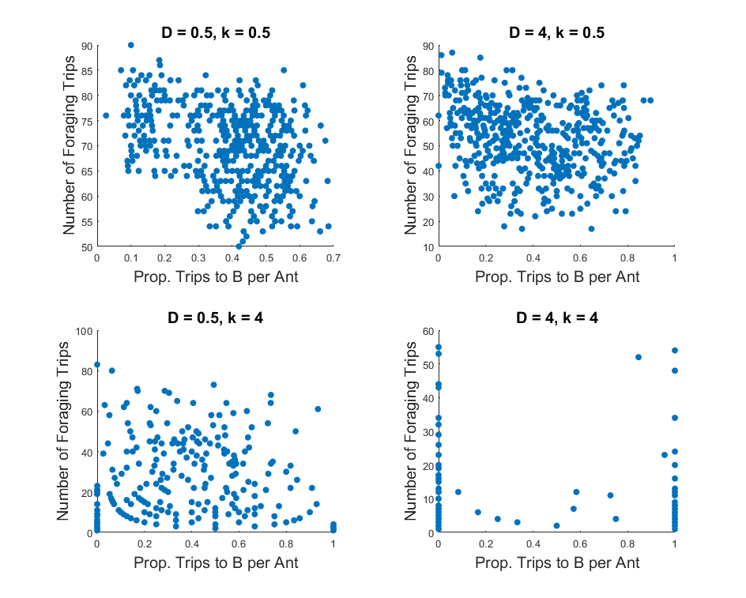

Figure 6. Simulations with different combinations of values for D and k.

**Wehner, R. (2020). Desert navigator. In *Desert Navigator*. Harvard University Press.**

**Pankiw, T., Page Jr, R. E., & Kim Fondrk, M. (1998). Brood pheromone stimulates pollen foraging in honey bees (Apis mellifera). *Behavioral ecology and sociobiology*, *44*(3), 193-198.**

**O'Donnell, S., & Foster, R. L. (2001). Thresholds of response in nest thermoregulation by worker bumble bees, Bombus bifarius nearcticus (Hymenoptera: Apidae). *Ethology*, *107*(5), 387-399.**

**Weidenmüller, A. (2004). The control of nest climate in bumblebee (Bombus terrestris) colonies: interindividual variability and self reinforcement in fanning response. *Behavioral Ecology*, *15*(1), 120-128.**

Wu, H., Li, H., Xiao, R., & Liu, J. (2018). Modeling and simulation of dynamic ant colony’s labor division for task allocation of UAV swarm. *Physica A: Statistical Mechanics and its Applications*, *491*, 127-141.

Jeanson, R., Fewell, J. H., Gorelick, R., & Bertram, S. M. (2007). Emergence of increased division of labor as a function of group size. *Behavioral Ecology and Sociobiology*, *62*(2), 289-298.